PROG POE – Part 3

Venkata Vikranth Jannatha

Varsity College – Cape Town

PROG7311

Table of Contents

Performance Enhancement for Prototype Agri-Energy Connection 4

Performance Optimization of Prototypes 4

Final software performance guidelines 6

Methodology for Agri-Energy Connect Platform 8

Clear Motivation for Agile Methodology 8

Platform Connection to Agri-Energy Integration 10

DevOps Integration Motivation 10

Agri-Energy Connect Platform Framework 12

Motivation for The Use of ITIL and TOGAF In the Agri-Energy Connect Platform 12

ITLL for Service Management 12

TOGAF for Enterprise Architecture 13

Interaction and Complementarity 13

Alignment with Project Objectives 13

Proposal Document Feedback 14

Technologies Used 14

Architecture 14

Key Features 15

Database Development and Integration 15

User Role Definition and Authentication System 16

Functional Features for Farmers and Employees 17

User Interface Design and Usability 18

Data Accuracy and Validation 19

Security Measures 20

Scalability and Performance Optimization 20

Testing and Quality Assurance 20

Business Value 20

1

# Performance Enhancement for Prototype Agri-Energy Connection

The Agri-Energy Connect platform aims to create a shared digital ecosystem for farmers and green energy technology providers. The performance of this platform is vital for its success because it determines user satisfaction and engagement. In this section, we will review honestly the prototype’s performance, pinpoint areas which require improvement, and indicate how the eventual software should operate at all.

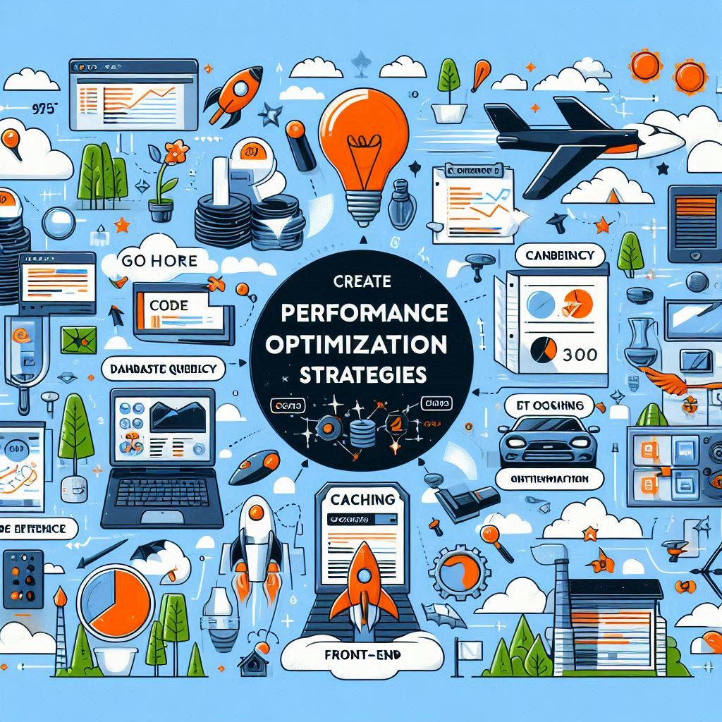

Figure 1 : Performance Optimization (Microsoft Co-pilot , 2024)

## Performance Optimization of Prototypes

Krysik (2024) argues that several key strategies exist to guarantee that the prototype operates efficiently and effectively thus optimizing its performance:

**Code Efficiency**: Improving code efficiency involves two key aspects as mentioned by Krysik (2024). To eliminate redundant or inefficient code segments in the codebase, review and refactor it. Through this process, application performance is not only increased but also its maintainability in general enhanced. Another important thing is algorithm optimization by ensuring that all algorithms are efficient and appropriate for given tasks in the application. This detailed plan for improving how the code works can result in a much better application performance.

**Database Queries:** Krysik(2024) insists on the importance of optimizing database operations for application performance. There are two major strategies. Query optimization is about evaluating and refining database queries including methods as indexing frequently accessed columns, excluding useless joins, and considering denormalization data when necessary. Moreover, revising and improving database structure is significant. It is important to study database structure, to make sure it helps store and access data in a good way, because this affects how well the software works in general.

**Caching:** As Krysik (2024) observed, the role of effective caching strategies cannot be overemphasized. Cache the server-side for dynamic content and consider Content Delivery Networks (CDNs) for statics. This will improve the performance of the application significantly. Consequently, a cache management strategy should be developed alongside its implementation. So, to balance the need for improved performance with data accuracy, this involves creating ways of invalidating caches as well as updating them.

**Front-End Optimization:** According to Krysik (2024), the front-end optimization involves two major areas. One of them is asset optimization, which refers to the process of improving the loading time for CSS files, JavaScript or image files used in a website. It can be done through minifying them or compressing the contents which leads to faster loading speeds. Additionally, it is equally crucial to enhance rendering performance. This means pinpointing and removing obstacles in the rendering process so that the user interface is more responsive, leading to a smoother and more efficient user experience.

## Final software performance guidelines

Figure 2 : Software Performance Guidelines (Microsoft Co-pilot , 2024)

To ensure acceptable performance of the final software, one must adhere to well-defined guidelines (Google Cloud, 2023):

**Performance Testing:** In 2023, (Google Cloud) revealed that all-encompassing performance testing remains fundamental in the detection and treatment of performance bottlenecks. This incorporates thorough load testing, stress testing and scalability testing too. For perpetual performance verification, professionals advise integrating performance testing through continuous integration and continuous deployment pipelines. This automated approach allows for consistent and regular performance checks throughout the development process.

**Monitoring and Profiling:** (Google Cloud, 2023) will have real-time monitoring and profiling given tremendous importance to it. This is because one way of doing this is by implementing monitoring tools which can keep an eye on live performance indicators like response time, load on the server, and error rate among others so that it can give out vital information concerning how well an application is functioning. At the same time using profiling tools makes it possible to pinpoint performance-critical parts in the code that require optimization. These practices make it possible for the developers to deal with performance issues rapidly and effectively.

**Scalability Considerations:** Google Cloud (2023) focuses on the place where we meet security and performance. To prevent slowness caused by security deficiencies, secure coding guidelines should be followed for developers and application security engineers to protect their apps as well as to protect it from other issues. It is advisable that companies should carry out security audits at least once every month to detect any things that might slow down the systems because of some problems with safety measurements reached during the time between reviews. Such an active approach helps guarantee the good condition of the application in both security and performance terms.

**Continuous Operation:** According to Google Cloud (2023), it is important to use their products continuously to make them better. This involves regular code reviews to identify ways in which performance can be made better as well as constantly monitoring performance metrics in real time. When issues arise, the program should deal with them immediately so that they do not degrade the system performance over time. By remaining committed to optimization, we can maintain the app’s optimum running state even in changing circumstances and variable requisites.

Improving the performance of the Agri-Energy Connect prototype is necessary for its success. Performance can be significantly increased if we concentrate on code efficiency, database query optimization, employing caching strategies, front-end optimization, and asynchronous operations as recommended in Krysik (2024). Moreover, adhering to the performance testing, monitoring, scalability planning, security considerations, and continuous optimization stipulations given by Google Cloud (2023) will make sure that the final software is reliable in terms of speed of operation and gives the users an integrated experience.

2

# Methodology for Agri-Energy Connect Platform

To make the Agri-Energy Connect Platform project development more efficient, I propose to use Agile software development methodology. Agile methodology is one that would be perfect for this project since it is rooted in iterative approaches and promotes both developers and stakeholders’ engagement heavily. In fact, rapid developments may be executed, of the software products, in response to changes in the customer needs.

## Clear Motivation for Agile Methodology

According to (Hunter, 2023), several benefits make the Agile methodology particularly appropriate for the Agri-Energy Connect project:

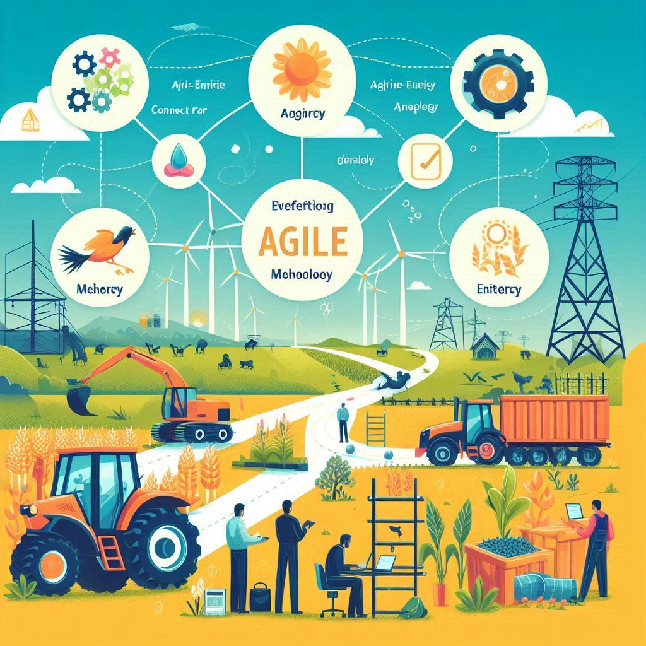

Figure 3 : Agile Methodologies (Microsoft Co-pilot , 2024)

**Client Collaboration**: Agile methodology espouses full-time interaction with the customer during project implementation. At the same time, this corresponds to the customer’s wish for a plan that fully captures all aspects of their proposal and ensures that the application they approve meets their objectives and goals. Through recurring interactions between customers, feedback is constantly given leading to instant corrections and improvements hence the eventual product suits customer demands and expectations (Hunter, 2023).

**Iterative Development**: In his article, (Hunter, 2023) mentions that Agile facilitates iterative development cycles, which necessitates feedback mechanism that is on-going. For a project of Agri-Energy Connect, this is important because of the lack of initial details. Thus, using Agile methods will make it possible for every member of the group working on the project to have an opportunity to improve upon existing requirements and provide small portions of value periodically as may be necessary depending on how it has been used together with the comments from clients."

**Adaptability to Change:** According to (Hunter, 2023), the agile approach adapts to changing requirements, a key feature in a platform with changing needs like linking up sustainable agriculture practices with green energy solutions. It allows for flexibility in incorporating new insights and adjusting the project direction as needed so that the final product remains relevant and effective.

**Focus on Delivering Value:** Being an Agile methodology implies that the software is delivered in short loops, working. The statement made by about this matter is in accordance with the objective of the sustainable ecosystem, which we will target green energy as the initial topic. One complicated thing, which is the most difficult and time-consuming to the client, however, they still do not miss their satisfaction and participation in it when they offer small pieces that are the signs of a certain type of progression or some modification of the form.

**Risk Mitigation**: According to Hunter (2023) Agile practices provide a good method to spot and solve the risks that occur the development process very early and thus in less tense conditions. This is of course important above all because such a project is designed to attract a variety of users based on the level of mastery of the technology and it is based on backend which is strong enough to take on data and interactions users scale live. By having early-issue resolution, the firm can avoid the more severe disruptions the team members would otherwise have to tackle in the later stage.

When creating the Agri-Energy Connect Platform, the team should consider using Agile methodology because it could foster cooperation, adjust to evolving needs, release value over time, and contain risks easily. The approach is in harmony with the customer’s desire to present a detailed proposal and a top-level scheme for the platform thus leading to a successful customer-focused growth process (Hunter, 2023). The strengths of Agile are evident in elements like client collaboration, iterative development, adaptability, focus on value delivery, and risk mitigation. For this reason, Agile is the best choice considering that it guarantees satisfaction of what should be produced by the client as well as acts as an effective linkage between sustainable agriculture practices and green energy solutions.

3

# Platform Connection to Agri-Energy Integration

Integration of DevOps into the development system is advisable for the purpose of Agri-Energy Connect Platform project. Being in line with the project objectives and requirements DevOps practices match with agile methodology and hence can lead to many advantages (Rini, 2024). To enhance the software development methodology by incorporating DevOps, here is a clear motivation for that:

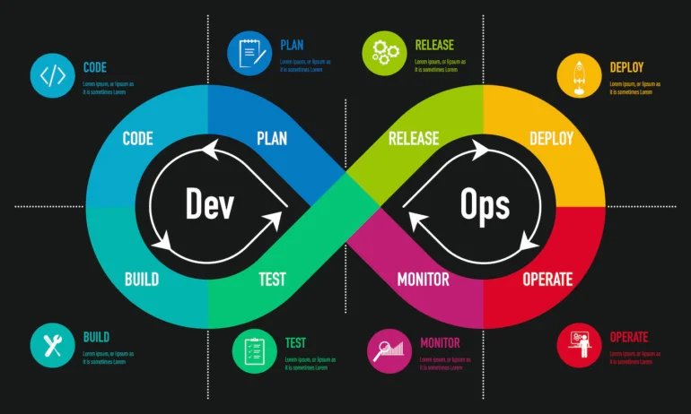

Figure 4 : DevOps Explain (Rini, 2024)

## DevOps Integration Motivation

**Continuous Integration and Deployment**: DevOps is highly rated for its concentration on continuous integration and deployment, which agrees well with the incremental and iterative nature of Agile methodologies. Through DevOps, the build, test, and deployment operations are made automated to enable quick production of software with short cycles that also consider changing demands as well as provide fast feedback.

**Collaboration and Communication:** According to Rini (2024), collaboration and communication between cross-functional teams is the reason for promoting DevOps in Agile development that collaborates closely with stakeholders. This is because this makes it easier for the team to respond quickly to changes through transparency, feedback loops as well as shared responsibilities when silos are brought down among development, operations, and other units.

**Efficiency and Quality:** According to Rini (2024), DevOps practices target increasing efficiency, reducing manual errors, and improving quality. Delivery of value to the client is of essence in an Agile environment, and DevOps does this by Optimizing processes, automating repetitive tasks, ensuring efficient software development, testing, and deployment. It ensures a high level of standards is kept during development yet maintaining burstiness and low perplexity.

**Risk Mitigation and Scalability**: The DevOps principles will help the development team in immediately detecting and fixing potential faults through Continuous Monitoring, Feedback Mechanisms, and Automated Testing. Such that, according to Rini (2024) DevOps is the practice that can scale and grow the reliability, performance, and scalability of a project such as Agri-Energy Connect which requires a sturdy back-end support and a smooth processing of the huge data size along with customer interaction.

**Alignment with Agile Principles**: Rini (2024) supports the claim that Agile principles are the same as DevOps's principles of customer collaboration, responding to change, and delivering working software. The deployment of DevOps as part of software development methodology enables faster team deliveries, improved product quality, and well-met customer needs and expectations.

When implementing the DevOps practices in Agri-Energy Connect Platform project within the Agile software development methodology, the team can improve collaboration, efficiency, quality, risk management, and scalability, hence providing a high-value solution that effectively meets the needs of the client. This dovetailing between them provides a united way to software development which concentrates on steady progression plus contentment of consumers (Rini, 2024).

4

# Agri-Energy Connect Platform Framework

The project Agri-Energy Connect Platform needs the combination of ITIL and TOGAF platforms for benefits to be realized. The reason for preferring these frameworks is given by Hajela (2023) through their values to this platform:

## Motivation for The Use of ITIL and TOGAF In the Agri-Energy Connect Platform

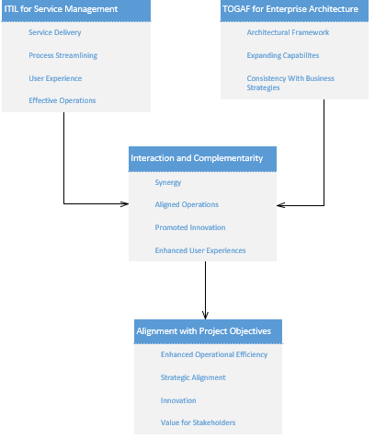

Figure 5 : ITIL and TOGAF Visual

### ITLL for Service Management

Focusing on service management, ITIL was cited to align well with the objective of Agri-Energy Connect Platform for creating a digital ecosystem facilitating collaboration between farmers and green energy tell by Hajela (2023). With adoption of ITIL practices, the platform can guarantee effective service delivery. It also streamlines process used in resource/information sharing while at the same time improves user experience. This will result in more efficient operations, happier users, and, consequently, meeting all the platform’s objectives.

### TOGAF for Enterprise Architecture

Hajela (2023) major point is that the concentration of TOGAF on enterprise architecture is of paramount importance for the Agri-Energy Connect Platform which is intended to connect sustainable agriculture and green energy technology providers. This platform can come up with a clearly defined architectural framework that entails expansion capabilities as well as consistency with business strategies through the exploitation of TOGAF. By allowing it to be such, with the evolution of a new market it becomes able to adopt the needed transformations, easily accommodate the latest technologies, and stay on top of the areas without causing any sustainability problem.

### Interaction and Complementarity

As indicated by Hajela (2023), combining ITIL and TOGAF will bring about an interaction which takes care of all the service management as well as enterprise architecture demands for Agri-Energy Connect Platform. ITIL makes sure that IT services are provided appropriately, and they agree with end users' demands. TOGAF gives an ordered strategy for development and execution of the system architecture. This synergy makes operations run better, lines things up in the interests and promotes innovation that are the key factors of the platform to be effective.

### Alignment with Project Objectives

According to Hajela (2023) when a digital ecosystem for collaboration, innovation, and the sharing of knowledge around sustainable farming and renewable sources of energy is desired, what helps the Agri-Energy Connect Platform is to use ITIL as well as TOGAF models in line with the project it supports. Aligning the platform results in improved functionality, scalability, and user experience, which create value for the company and all its stakeholders.

We can make use of both ITIL for service management as well as TOGAF for enterprise architecture to enhance the Agri-Energy Connect Platform project implementation. It will result in enhanced operational efficiency, strategic alignment, and innovation to develop digital ecosystem uniting sustainable agriculture and green energy solutions.

5

# Proposal Document Feedback

The creation of The Agri-Energy Connect Platform prototype was made to foster a strong digital ecosystem that links eco-energy technology suppliers with the farmers. With this technical solution, sophisticated web solutions, scalable architecture, and secure data governance practices have all been combined to provide a continuous user experience.

## Technologies Used

Visual Studio was utilized in making a prototype of the system through an ASP.NET MVC project, making sure that the codebase is structured and maintainable. The back-end logic was written on C#, which allowed for strong and efficient server-side processing. An SQL server was employed in the development of the relational database, for consistent and expandable data handling.

## Architecture

Figure 6 : Visio Architecture Flow

The platform follows a Model-View-Controller (MVC) architecture, which separates the application into three main components: the model (data), the view (UI), and the controller (business logic). This architecture ensures that the platform is modular, scalable, and maintainable.

## Key Features

### Database Development and Integration

Figure 7 : Visio Table of Farmers and Products

The design and integration of the relational database were parts of the project which had the main purpose of the effective information storage and retrieval about the farmers and their products. A well-arranged database was used to gain the collection and assembling of data that was about agricultural activities and outputs. In doing this, a visually strong and thorough demo scenario was created, where the database was filled with sample data that imitated the situations as if they were. Thanks to this way of working a situation was the system's capabilities was created and thus it was a more precise and clearer demonstrator of the platform use cases. The inclusion of sample data was a very useful tool for the database which, as а result, Farmer indicates the relationships as well as its potential to comprehend various and difficult data on agriculture. Thus, this statically provides the necessary support of the output of the technology.

### User Role Definition and Authentication System

Figure 8 : Visio Flow diagram of Roles.

A user-friendly system was developed with two different types of user profiles for the benefit of the end-users. On one hand, the farmers who are the one of the user types can insert their products and look on their product lists, which in turn means they can manage their own agricultural exchange in a more cost-effective way. The other user role, Employee, was designed with more functions, they can add new farmer data to the system, view all products from specific farmers, and utilize filters for fast products searching. Apart from implementing a secure login function with ASP.NET Identity, the concern of data security and accessibility for role-specific data was adroitly addressed. This great identification system guarantees the guarded of sensitive data but also makes certain that customers can get into the data that they are supposed to use as well as the functions that their job in Agri-Energy Connect Platform has.

Functional Features for Farmers and Employees

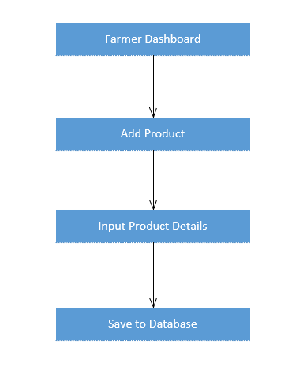

Figure 9 : Visio Flow of Employee's and Farmer's

The product was upgraded to include custom functionality for the farmer and employee user roles. Product addition was performed on the farmer's side, and in this context, they were allowed to enter the new products inserted into the system with ease. This attribute is the feature of allowing the farmers to add the necessary details such as the product name, category, and production date, which permit a summary of the whole agriculture produce. As for the employee's end, the system was designed to allow employees to add details of new farmer profiles. Moreover, the employees were given the feature in real-time to filter the sun list and narrowly get products interregional and across farmers in the system. With this advanced filtering system, workers can easily separate and search for the merchandise based on specific criteria, time spans and product types, respectively, so they can perfectly and quickly be able to efficiently manage and analyse agricultural data within the Agri-Energy Connect Platform.

### User Interface Design and Usability

|  |  |
| --- | --- |
|  |  |
|  | |

Figure 10 : UI/UX of Employee's and Farmer's Dashboard

The development process was mainly concerned with the creation of a user-friendly interface that entails intuitive navigation and a clear layout such that users can easily interact with the Agri-Energy Connect Platform. To make sure it can be accessible on several devices like laptops, tablets, and smartphones, and one of the methods that were applied to it was responsive design with the help of Bootstrap. This method ensures the platform is not only functional but also visually appealing irrespective of the user's device. Moreover, ASPX files were significantly improved, and the focus was mainly on the UI part to get a pure and professional look. We made sure that it is presented neatly and accurately, whereby, upgrading the user experience and the platform is made efficient while giving it a sleek appeal to the viewers, who are either farmers checking on their products or employees running profiles for them and storing the product data.

## Data Accuracy and Validation

Figure 11 : Visio Flow Diagram Validation

Robust data validation checks that were added to the Agri-Energy Connect Platform have been found to be important for preventing failures and errors, ensuring stable system operation. These checks keep users from submitting inaccurate data or entering inconsistent data into the system, which in turn prevents such data from being stored. Also, we have launched full-based error-handling strategies to guard against system crashes and possible data corruption. These components not only improve the reliability of the platform but also help users avoid issues by keeping it running smoothly and ensuring the safety of the parallel agricultural and energy-related data managed by the system itself.

## Security Measures

To ensure the data security, part of our work to implement the secure user authentication and role-based control to ensure data privacy and security for the reservation of possible tools, has been done by security measures in the form of a full sixteen-step software process.

Scalability and Performance Optimization

Not only by caching did we manage to reduce the server load and consequently, the response time was improved but also the database queries optimization with (DI) and the use of the filling of the gaps on the back-office side were taking place.

Testing and Quality Assurance

The achievement of the desired level of quality and maturity of the test environment can be attributed to having frameworks for both the front end and back end automation testing in place, integration, unit and functional testing early in the development stage of every single code for which a code completion tool supports in smart mobile device software engineering (SMDS) environments, and successful integration with mobile device software engineering (MDSE) environments.

## Business Value

These are the important business values that Agri-Energy Connect Platform

**Connecting Stakeholders**: Through the collaboration of farmers and green energy technology providers, eco-friendly practices are applied, leading to the increase of crops and the decrease in the pollution of the environment.

**Enhancing Collaboration**: The Chat tool and Near Field Communication allow the farmer to transfer the knowledge and experience that play a major role in best and efficient practices for sustainable agriculture.

**Streamlining Access to Resources**: The available online market and educational resources guarantee a smooth and quick access for farmers toward not only appropriate instruments, but how they can take the efficient measures of transforming to green technology.

**Ensuring Security and Trust**: Building the trust of the customers through secure systems is a top priority for the business to stay safe and secure, it brings out more ways to ensure private data protection and cyber secure.

**Scalability**: For all project sizes, the platform is intended to gradually become flexible enough as the user base increases so that it can support more data and handle more traffic without any sacrifice in functionality.

**User-Friendly Experience**: The platform's user-friendly design attracts more users, thus, increasing customer satisfaction and interaction that, in return, leads to more farmers using the platform.

# References

Google Cloud, 2023. *Performance optimization process  |  cloud architecture center  |  google cloud.* [Online]   
Available at: https://cloud.google.com/architecture/framework/performance-optimization/process  
[Accessed 26 June 2024].

Hajela, S., 2023. *TOGAF And ITIL: Enhancing Enterprise Architecture And IT Service Management.* [Online]   
Available at: https://cioindex.com/reference/enterprise-architecture-with-itil/  
[Accessed 27 June 2024].

Hunter, T., 2023. *11 benefits of Agile Methodology.* [Online]   
Available at: https://builtin.com/articles/benefits-of-agile  
[Accessed 26 June 2024].

Krysik, A., 2024. *How to achieve fast web application performance: 10 practical tips for developers.* [Online]   
Available at: https://stratoflow.com/how-to-speed-up-web-application-performance/  
[Accessed 26 June 2024].

Microsoft Co-pilot , 2024. *Co-pilot | Designer.* [Online]   
Available at: https://copilot.microsoft.com/images/create/create-an-picture-22performance-optimization-strate/1-667d7bce29d4402e8eff3c6228d1e4d4?FORM=GUH2CR  
[Accessed 27 June 2024].

Rini, N., 2024. *What are the benefits of DevOps?.* [Online]   
Available at: https://www.techrepublic.com/article/devops-benefits/  
[Accessed 27 June 2024].